**Experiment 1.3 Paul Thomas 30 S3 CSB**

**Program**

| public class matrixMulti{  public static void main(String[] args) {  int a[][] ={{1,1,1},{2,2,2},{3,3,3}};  int b[][] = {{1,1,1},{2,2,2},{3,3,3}};  int c[][] = new int[3][3];  System.out.println("\nMatrix A\n");  for (int i=0; i<3; i++){  for(int j=0; j<3; j++){  System.out.print(a[i][j] + "\t");  }  System.out.println();  }  System.out.println("\nMatrix B\n");  for (int i=0; i<3; i++){  for(int j=0; j<3; j++){  System.out.print(b[i][j] + "\t");  }  System.out.println();  }  System.out.println("\nMatrix A x B\n");  for (int i=0; i<3; i++){  for(int j=0; j<3; j++){  c[i][j]=0;  for(int k=0; k<3; k++){  c[i][j] += a[i][k] * b[k][j];  }  System.out.print(c[i][j] + "\t");  }  System.out.println();  }  }  } |
| --- |

Program

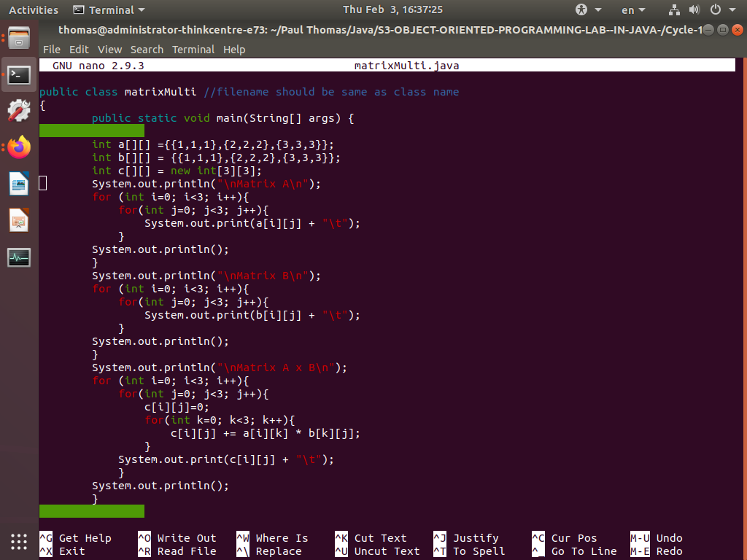

Output

